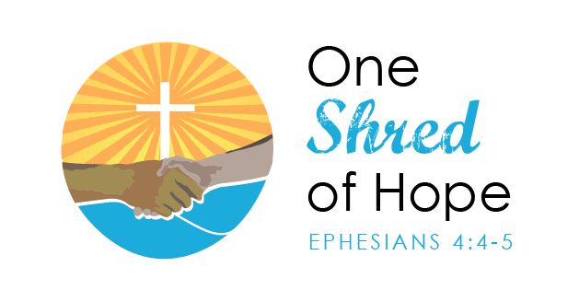

Golf Tournament Hole Sponsorship Form
Saturday, October 13, 2018
Halifax Holes
All proceeds will be used to provide housing for individuals with disabilities.

I would like to sponsor ___ holes at $100 each.

____ Check Enclosed for $_____ payable to One Shred of Hope.

____ Please charge my credit card $_____
_________________ ______ ______
Credit Card # Exp.Date CVC #

Business/organization name to be printed on sign at hole:

___________________________________________________

Name/Position: _________________________________

Address: ____________________________________________

Phone #: ________________ Email: ______________________

For more information call: Lauren Compere, Development Director, 601-832-8927
Email completed forms to lcompere@oneshredofhope.org
Mail completed forms to: P.O. Box 688 Clinton, MS 39060

